**Exp: 7**

**Title: Write a CPU bound C program and a I/O bound C program and observe the effect of their CPU share using the top command and its variants**

* CPU Bound C Program

1. #include<stdio.h>

#include<time.h>

int main() {

clock_t start,end;

double runtime;

start = clock();

int i,num=1,primes=0;

while(num<=10000000){

i=2;

while(i<=num){

if (num%i==0)

break;

i++;

}

if (i==num)

primes++;

//clear("clear");

printf("%d prime numbers calculated\n",primes);

num++;

}

end=clock();

return 0;

}

Output:

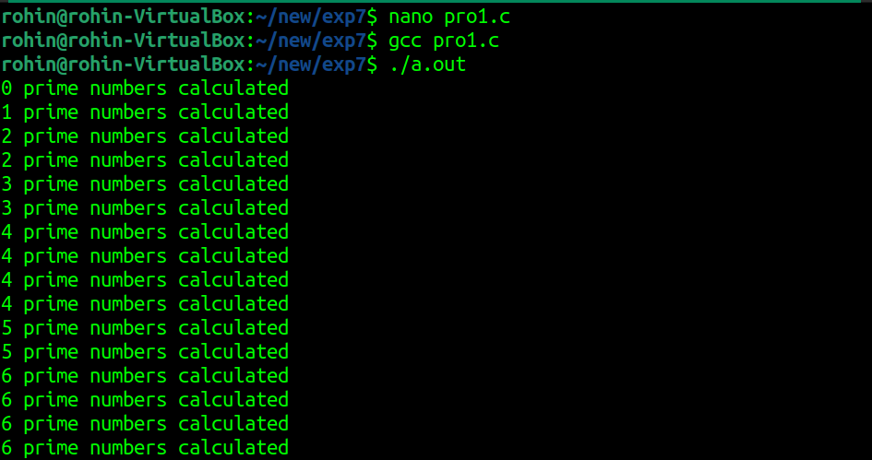

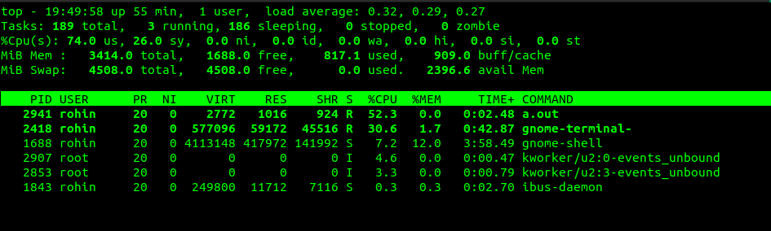

1. #include<stdio.h>

int main() {

int ResultantMatrix[4][4],i,j,k; //matrix calculation

int matrix1[4][4]={ {2,23,23,45},

{66,45,3,23},

{3,5,89,67},

{4,4,9,7} };

int matrix2[4][4]={ {3,5,6,4},

{64,89,56,2},

{56,26,56,99},

{90,7,43,2} };

while(1) {

for(j=0;j<4;j++)//matrix multiplication

{

for(i=0;i<4;i++) {

ResultantMatrix[i][j]=0;

for(k=0;k<4;k++)

ResultantMatrix[i][j]+=matrix1[i][k]+matrix2[k][j];

printf("result=%d",ResultantMatrix[i][j]);

} } } }

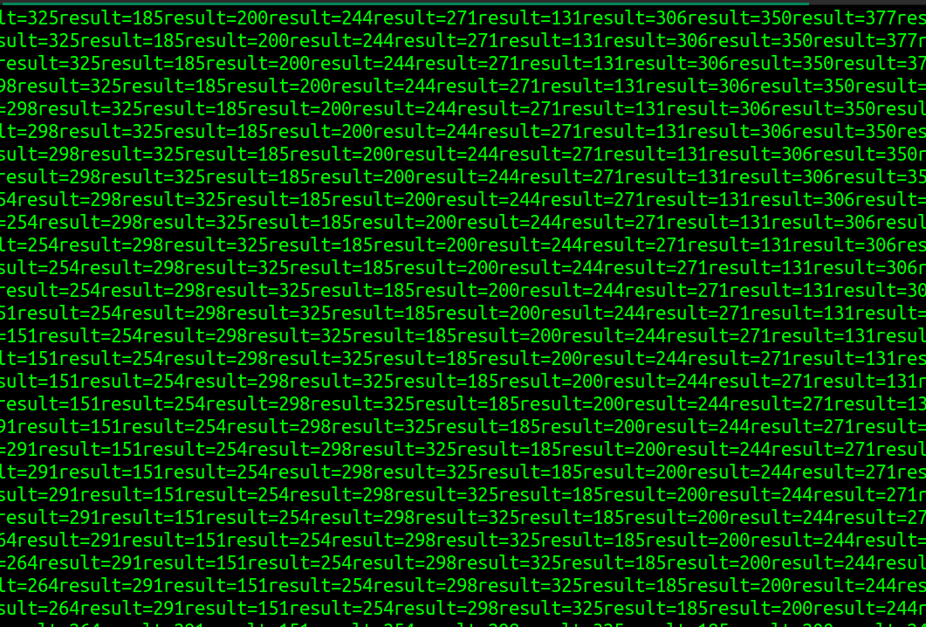**Output:**

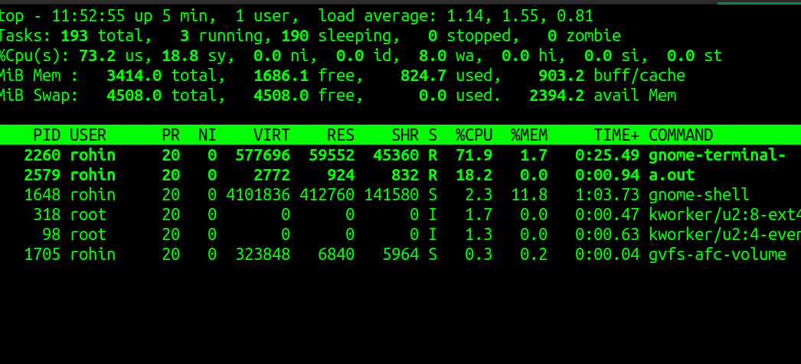

* I/O Bound C Program

#include<stdio.h>

#include<time.h>

int main()

{

int j,k,n;

while (1) { //infinite loop

printf("\nEnter any number : "); //taking input

scanf("%d" , &k);

printf("enter any number :");

scanf("%d" , &j);

n =k%j ; //calculation

printf("%d", n);//printing the result

time_t rawtime; //displaying the current time

struct tm * timeinfo;

time(&rawtime);

timeinfo = localtime ( &rawtime );

printf("\nCurrent local time and date : %s",asctime

(timeinfo) ); //printing the current time

}

}

Output:

